Rathnayake Rathnayake - 10899210

Project proposal

Sri Lankan tea export company

Business process we identified - quality grading of tea

Promotion and tourism

Introduction

Sri Lanka's tea export sector is well known across the globe for its superior tea offerings. However, it is essential to continuously improve critical procedures like tea quality grading and promotion in order to preserve and strengthen its competitive edge in the worldwide market. The objective of this project is to assess current procedures objectively, pinpoint their shortcomings, and suggest improvements that are backed by an information system solution.

1. Tea Quality Grading Process

An exacting and crucial step in the manufacturing and export of Sri Lankan tea is the grading of tea quality. To ascertain the quality grade of tea batches, a meticulous assessment of many factors such as taste, aroma, appearance, and texture is required. Tea tasters with years of experience, sophisticated palates, and in-depth knowledge of tea characteristics carefully evaluate each parameter.

In order to evaluate a tea's flavour, tasters do a sensory analysis in which they weigh characteristics including body, sweetness, bitterness, and astringency. The evaluation of aroma is centred on the scent released by the tea leaves, which can differ based on quality, processing technique, and provenance. Examining the tea leaves' colour, size, shape, and uniformity—all of which give visual clues about their quality—is part of the appearance assessment process.   
  
Maintaining Sri Lankan tea's reputation in global markets requires consistent grading of tea quality. Strict adherence to quality standards guarantees that every batch of tea fulfils the demands of discriminating consumers around the globe. Sri Lanka remains a top exporter in the world tea market by continuously producing high-quality tea products.

* Different types of Ceylon tea

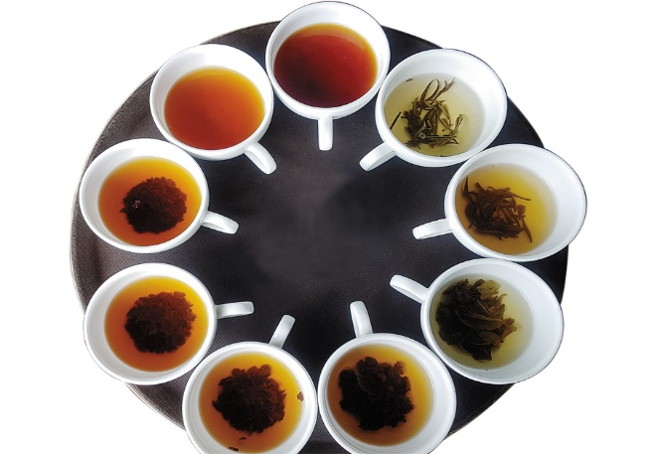 <https://www.forbesindia.com/media/images/2020/Jan/img_127041_typesofceylontea.jpg>

1. Promotion and Tourism Process

In order to draw tourists to the attractive tea estates dotted around the island and highlight the distinctive qualities of Sri Lankan tea, promotion and tourism are essential processes. It includes a variety of marketing campaigns meant to increase consumer knowledge of Sri Lankan tea goods and provide travellers with unique travel experiences.

The tourism component aims to attract visitors to Sri Lanka's tea country and provide them with immersive experiences at tea farms, in addition to promoting tea goods. Tea factories provide guided tours for tourists so they may see the entire tea-making process, from picking tea leaves to packing them. Along with delighting in the breath-inspiring surroundings, they can stroll through verdant tea gardens, engage with tea pluckers, and have freshly brewed cups of Ceylon tea.  
  
In addition to increasing Sri Lankan tea's market penetration and sales, successful marketing helps the nation's tourism sector by creating jobs and income in the tea-producing areas. Additionally, it encourages foreign visitors to appreciate Sri Lanka's rich tea tradition and to exchange cultures.

* picture of a Sri Lankan tea packaging showcasing a traditional Sri Lanka tea shop for promotional purposes.

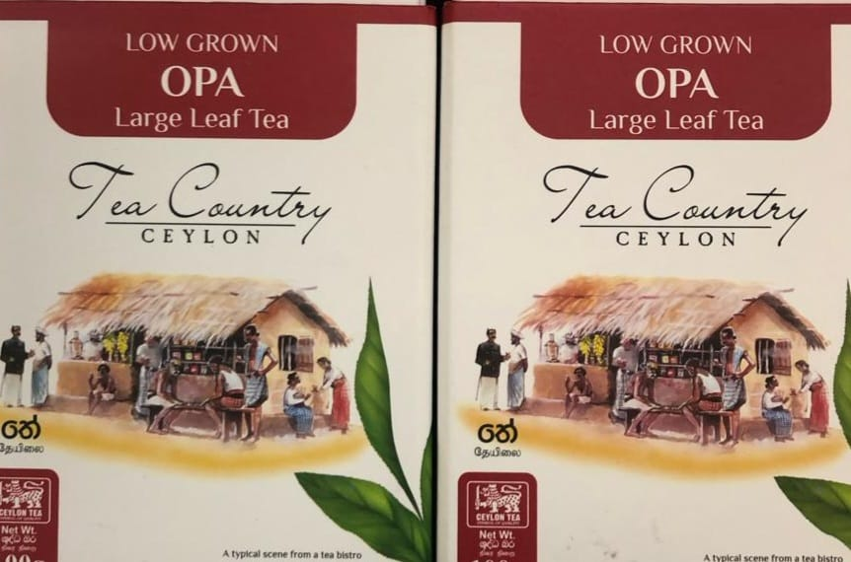

The Sri Lankan tea export sector depends heavily on the processes of grading and promoting tea quality. Improving these procedures will raise market awareness, draw more tourists to tea-producing areas, and guarantee the constant quality of tea goods. Our goal is to enhance the competitiveness, sustainability, and growth opportunities of the Sri Lankan tea export business by concentrating on these processes.

Our strategy for improving the systems for grading and promoting tea quality in the Sri Lankan tea exporting sector is laid out in this project plan. Through comprehensive investigation, vulnerability analysis, improvement suggestions, and information system prototype development, our goal is to support the expansion and competitiveness of Sri Lanka's tea export sector.  
  
the GANNT chart

